INTERIM REPORT

An FYP interim report is a report on the current progress of the final year project. It main role is to document what have been achieved so far and the things that need to be done later on.

Note that the FYP interim report should be 5-10(A4) pages.

Suggested format

1.Introduction

•Provide some background information on the project, the purpose (why it is carried out), the scope of the project and the objectives of the project to help readers understand your project better.

•Include the timeline for the completion of the project (your project plan/strategy)

•State the purpose of the interim report.

2.Work Conducted

•Highlight the work that you have done so far.

•Highlight your achievement and the effort put in.

•Discuss potential problems encountered and the things that hampered the progress of the project.

3.Future Work

•Describe the work that is in progress and the work that needs to be done.

•Highlight changes made to the original requirements of the project.

4.Conclusion

•Comment on the progress of the project.

•Do an honest assessment.



School of Electrical and Electronic Engineering

FYP Interim Report

Submitted by: Bryan Tan

Matriculation Number: U1722930H

1. Introduction

The purpose of this project is to create an interactive display that can be used to show what software and hardware can do together. The interactive display should be something interesting and unique. Thinking along these lines whilst getting inspiration from the game “Pong” and Pinball, the idea was to build a physical 2 player pinball like game with 1 player being human and the other being the computer.

1.1 Scope

The project will consist of a physical game board that the player controls from one side. The score will be tracked on a scoreboard mounted beside the board itself. The opponent is a computer that is able to know when to hit the ball based on various sensors.

1.2 Objective

The objective is to create a physical 2 player game in which one side is controlled by a human and the other by the computer.

1.3 Timeline





Table 1: Double click icon to scroll through in Excel

1.4 Interim Report Purpose

The purpose is to provide the reader with information on what the project is and how it is progressing. It also covers the work conducted, including the issues faced, and the future work to be completed before the end of the project.

1. Work Conducted

2.1 Work Completed

The work completed can be broken down into 4 main components. Testing of the flipper mechanism, building the gameplay board, miscellaneous testing and object tracking. All the components were tested on an Arduino board. An Arduino board was chosen as most modules and sensors are easily interfaceable with Arduino. Besides the modules, there are also many variants of Arduino boards, meaning that should the project have a need to be used with Wi-Fi, the current board can easily swapped out for one that is Wi-Fi capable.

2.1.1 Testing of flipper mechanism

Typical flipper mechanisms make use of a specialized solenoid with 2 coils around the same core [1]. One coil is for the flipper to be strong enough to hit the ball while the other is to hold the ball in place should the player press and hold the flipper button. It is necessary to have 2 coils as powering the stronger coil for a long period of time will cause it to be burnt out. This design of flipper is very specialized hence it was not possible to use the same mechanism in this project. This narrowed down the mechanisms to be either a DC motor with an encoder or a servo motor. A DC motor with an encoder would allow the DC motor to have precision positions set which allows the flippers to have a set rotation [2]. However, with the flipper having such a small range of motion, it would not be necessary to use a DC motor. The final solution of using a servo motor was thus chosen to be used as a flipper.

The SG90 micro servo was chosen. It has an operating voltage of 5V with a running current of about 220mA and stall current of 650mA [3]. To ensure it does not reach the stall current, two aspects were carefully considered. First, the ball chosen had to be light enough not to be affected much by air currents yet solid enough to move a decent distance when hit by the flipper. Second, the movement of the flippers when hitting the ball should not hit its maximum of +-90 degrees. Therefore, the total current needed for the 4 flippers should all of them be moving simultaneously is 220mA*4 giving a total of 880mA.

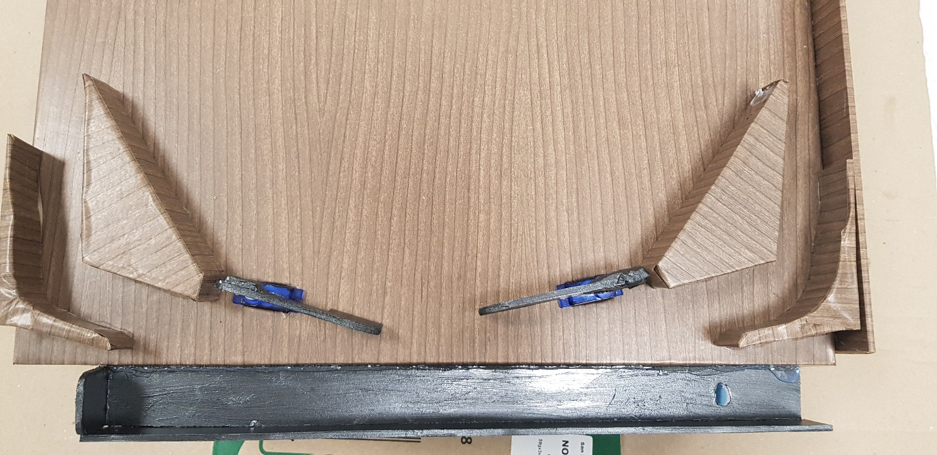

Figure 1: 2 Flippers on each side

A typical configuration would be to power the servos separately and have each servo connected to one pin on the Arduino. This would use up 4 pins on the board and would increase if I used more servos. To reduce the number of pins needed for all the servos, a PCA9685 I2C interface driver was chosen.

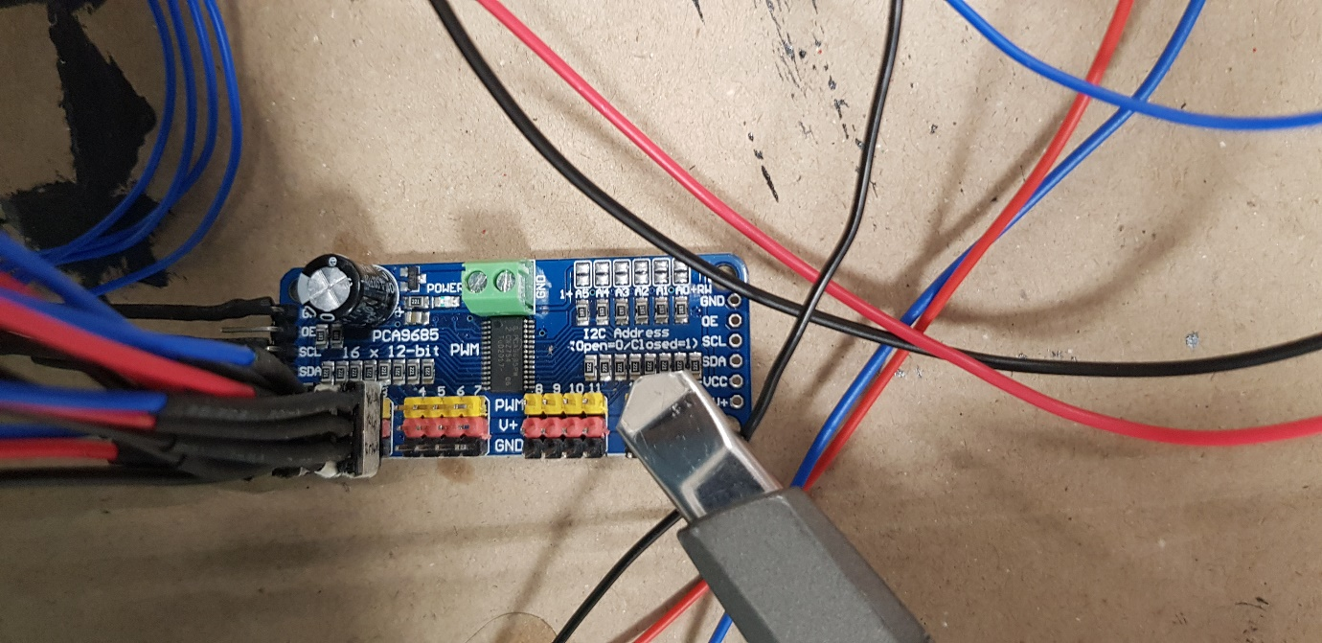

Figure 2: PCA9685 board

The PCA9685 driver can drive up to 16 servos with only 2 pins, through the usage of the I2C communication protocol. The 2 pins being the serial data (SDA) and the serial clock (SCL) on the Arduino board. Another reason for using the PCA9685 is to allow other modules using I2C protocol to chain with this and reduce the need for another 2 communication pins [4].

2.1.2 Building the gameplay board

The gameplay board is constructed to be easily portable thus the main frame of it is made of extruded foam. This makes the entire structure lightweight yet strong enough to hold the weight of the various components mounted on it. The selection of balls was another item taken into consideration. 4 balls of varying size and materials were taken into consideration. Out of the 4, the medium sized plastic ball was chosen as it did not stick to the board due to static.

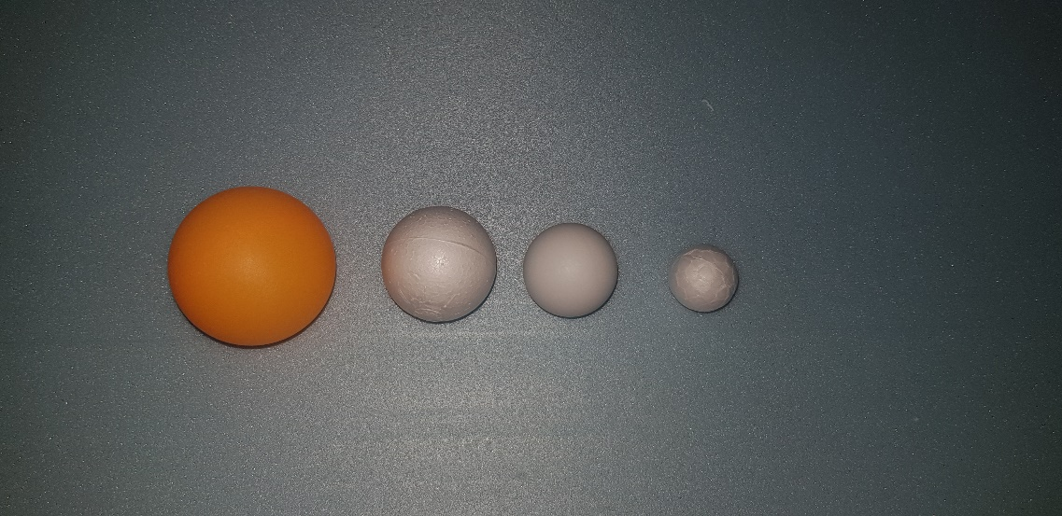

Figure 3: Type of balls considered, 3rd from the left is the chosen ball

Testing was also done to determine the angle that the board should be at to allow the ball to slide down at a reasonable speed and not get stuck. This was determined to be an angle of 2.15 degrees. To achieve this, blocks of different heights were used as legs.

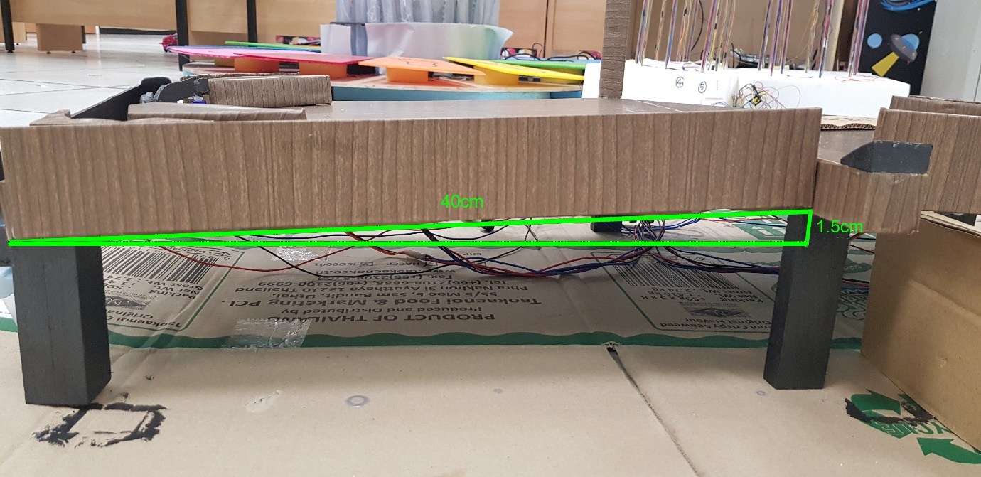

Figure 4:Gameplay board

To achieve an angle of 2.15 degrees, the following calculation was done, ,meaning that the height difference of the front and back of the board had to be 1.5cm while the board was to be 40cm long. Having this angle the speed of the medium plastic ball works out to be on average 0.2m/s.

2.1.3 Miscellaneous testing

Other than the main parts of the flippers, there were 2 other components that were tested and used. These are, infrared sensors and a 4-digit 7 segment LED. The infrared sensors are used to count the scores when the ball passes the flippers. The infrared sensors are a repurposed line tracer module which work digitally and activate when an object is in front of it.

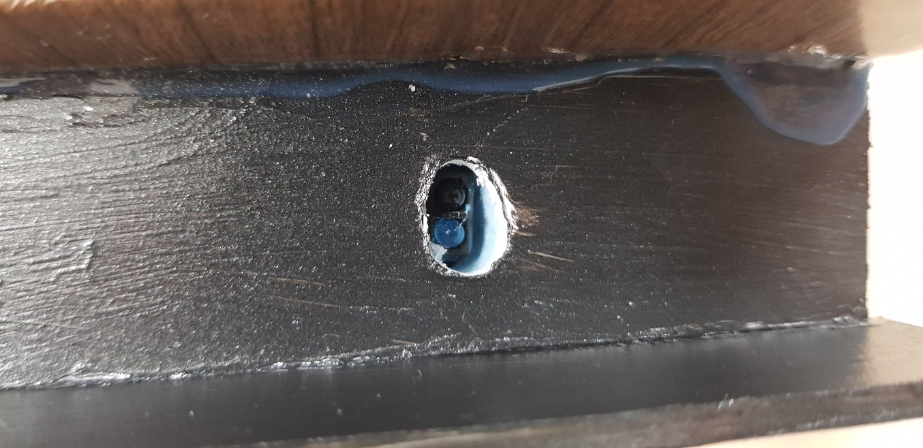

Figure 5: Infrared sensor

The 4-digit 7 segment LED is used to show the scores for each side of the board. To reduce the number of pins needed, the 4-digit 7 segment LED is controlled by a TM1637 driver. This driver allows the control of all 4 digits using only 2 pins with the two-wire bus interface. For all intents and purposes, this is the same as the I2C protocol mentioned earlier except it does not have a slave address so it cannot be chained with the I2C modules [5].

2.1.4 Object Tracking

Much research was done on the best way to achieve object tracking. The solutions ranged from using a Raspberry Pi with OpenCV to using multiple range sensors, either ultrasonic or infrared, to triangulate the position of the ball. However, after much testing it was determined that the triangulation method was too inaccurate as the infrared light was interfering with each other and using an additional Raspberry Pi just to do object detection with OpenCV was deemed not cost effective. Therefore, to achieve object tracking, a chip with the TinyYOLOv2 model was used. TinyYOLOv2 takes an image of size (416 x 416) and outputs class probabilities and bounding box coordinates [6]. The original YOLOv2 uses 24 convolutional layers while the TinyYOLOv2 uses 9 convolutional layers and 6 max-pooling layers.

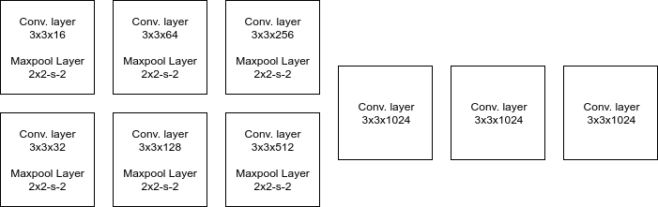

Figure 6: TinyYOLOv2 Architecture

This means that while the original is more accurate, the TinyYOLOv2 is faster and takes up less processing power. The model is put on a Kendryte K210 processor which allows for ease of use. The processor is then integrated with a camera and produced as an entire module called “HuskyLens”. The HuskyLens is able to communicate via either UART or I2C with the Arduino. As mentioned previously, to reduce the number of ports needed, the HuskyLens will be chained with the PCA9685 using the I2C ports. This will be used to detect the ball and determine when to use the flippers for the side controlled by the computer.

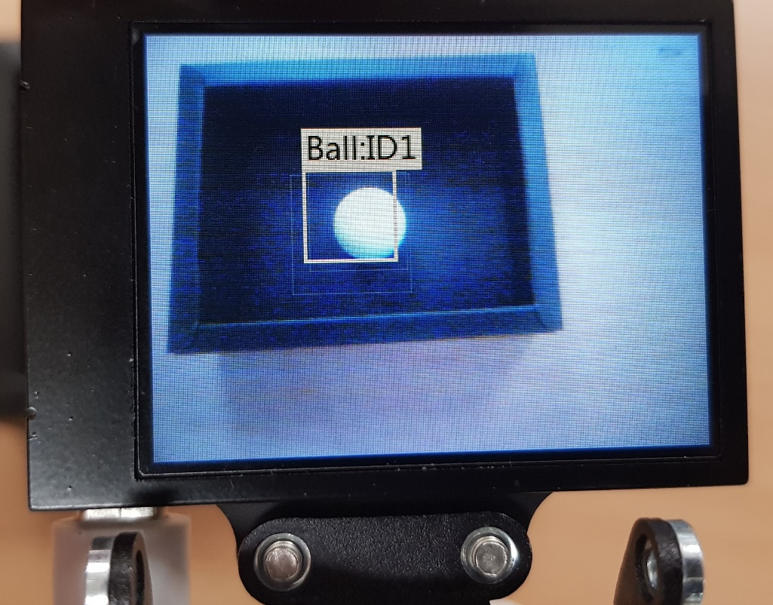

Figure 7: Tracking of the ball

1. Problems Encountered

Being unfamiliar with all the various protocols used for communications with the Arduino and components meant that I had to do a lot of research on the benefits of each protocol. These protocols ranged from UART, I2C, Serial over wire, etc. There was also a need to source for a driver for the servos as running 4 servos directly from the Arduino board will cause it to burn out due to the required current being over the limit of what it can take. There was also issues with regards to the object tracking model as I was completely new to object tracking and AI. Lastly, was the non-technical issues like the consideration of the materials, whether they were smooth enough for the ball to roll and whether it was strong enough to be moved without breaking among others.

1. Future Work

The main structure of the board, the flippers and the scoreboard are completed. What is left is the obstacles on the board, programming the computer based on the object tracking and improving the aesthetics. Currently, no changes have been made to the original requirements of the project.

1. Conclusion

Based on the proposed timeline, the project is slightly behind time. This was due to a couple of factors, namely, the long shipping time of the parts and unfamiliarity of the parts used. This meant that I had to spend more time researching and testing out the parts before including them inside the project. However, with regards to the challenges faced, I think the delays were reasonable.

# References

|  |  |
| --- | --- |
| [1] | M. Gibson, "Fun With Pinball," Fun With Pinball, n.d. n.d. Circa. 2020. [Online]. Available: https://www.funwithpinball.com/learn/flippers-coils-and-power. [Accessed 30 October 2020]. |
| [2] | M. Murray, "The Geek Pub," The Geek Pub, 15 December 2019. [Online]. Available: https://www.thegeekpub.com/245407/how-rotary-encoders-work-electronics-basics/. [Accessed 2020 October 2020]. |
| [3] | Opencircuit, "Opencircuit," n.d.. [Online]. Available: https://opencircuit.shop/Product/TowerPro-SG90-9G-micro-servo-motor-180. [Accessed 30 October 2020]. |
| [4] | SFUptownMaker, "I2C," [Online]. Available: https://learn.sparkfun.com/tutorials/i2c. [Accessed 2 November 2020]. |
| [5] | Titan Micro Electronics, "LED Drive Control Special Circuit," 2015. |
| [6] | Y. J. Wai, Z. b. M. Yussof, S. I. b. Salim and L. K. Chuan, "Fixed Point Implementation of Tiny-Yolo-v2 using OpenCL on FPGA," *International Journal of Advanced Computer Science and Applications,* vol. 9, no. 10, pp. 506-512, 2018. |